**2018 Physics Year 11 Examination marking guidelines**.

Marking Guidelines and Model Answers.

**Section I Multiple Choice**

|  |  |  |  |  |  |  |  |  |  |  |  |  |  |  |  |  |  |  |  |
| --- | --- | --- | --- | --- | --- | --- | --- | --- | --- | --- | --- | --- | --- | --- | --- | --- | --- | --- | --- |
| **1** | **2** | **3** | **4** | **5** | **6** | **7** | **8** | **9** | **10** | **11** | **12** | **13** | **14** | **15** | **16** | **17** | **18** | **19** | **20** |
| **B** | **D** | **C** | **B** | **D** | **A** | **A** | **B** | **B** | **A** | **C** | **C** | **C** | **B** | **D** | **B** | **D** | **A** | **B** | **B** |

**Part B**

**Booklet 1: Nicola**

**21.a.**

|  |  |
| --- | --- |
| **Marking Criteria** | **Marks** |
| * All forces acting are shown correctly. Forces have to be in pairs. Diagram has to be labelled | **2** |
| * Friction force only is shown OR one pair of forces. Diagram has to be labelled | **1** |

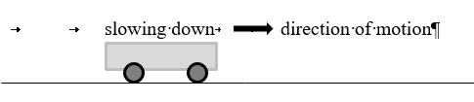

friction

(possible forward force)

normal force (force of table on trolley)

weight

Marker feedback: (current average: 1.36)

Most students did not identify the second pair of forces.

**21.b.**

|  |  |
| --- | --- |
| **Marking Criteria** | **Marks** |
| * Calculation is correct | **2** |
| * Calculation attempted but error made or negative direction not given or units omitted | **1** |



Marker feedback: (current average: 1.48)

Correct answer only accepted.

**21.c.**

|  |  |
| --- | --- |
| **Marking Criteria** | **Marks** |
| * correct quantity identified | **1** |

mass of trolley. Weight accepted.

Marker feedback: (current average: 0.65)

The question was generally answered well.

**Marker Feedback:**

**22.a.**

|  |  |
| --- | --- |
| **Marking Criteria** | **Marks** |
| * role of friction is described for all 3 situations given (accelerating, moving around a corner and stopping) | **2** |
| * role of friction is partly described or described for some of the situations only | **1** |

When acceleration is happening, the tyres are pushing back on the road so the road pushes forward on the car. When cornering, the road must be able to exert a sideways force on the car through the tyres without slipping, and when stopping the tyres must be able to exert a forward force on the road so the road surface exerts a backwards force on the tyres, again, without slipping which could not happen without friction.

Marker feedback: (current average: 0.89)

The common error in this question was omitting to describe the role of friction for all 3 identified situations.

**22.b.**

|  |  |
| --- | --- |
| **Marking Criteria** | **Marks** |
| * acceleration is calculated using a correct method | **2** |
| * acceleration calculation is attempted but an error or omission is made or answer is given without units | **1** |

 

note that same answer obtained using *a* = 0.75 x g

Marker feedback: (current average: 0.44)

Correct answer only accepted. Many students calculated 8820N but did not take it further. An attempt needed to be made at the second calculation for marks to be achieved.

**23.a.**

|  |  |
| --- | --- |
| **Marking Criteria** | **Marks** |
| * conservation of momentum is used and * calculation shows that momentum =0 for system | **2** |
| * conservation of momentum is referenced   OR   * an appropriate or relevant calculation is attempted | **1** |

Momentum of system before collision = momentum of system after collision, so: 800 kg x 12.0 m s-1 + 960 kg x -10.0 m s-1 = 0

Therefore, as p = 0, entangled wreckage is stationary.

Marker feedback: (current average: 1.11)

The question was answered reasonably well. Some students did not demonstrate momentum = 0. Students are advised to fully read the question.

**23.b.**

|  |  |
| --- | --- |
| **Marking Criteria** | **Marks** |
| * explanation is correct and supported by relevant equations | **2** |
| * explanation in words only or only a correct equation given with no explanation | **1** |

EK before collision = ½ x 800 x 12.02 + ½ x 960 x 10.02 = 1.06 x 105 J. The final EK of the system as v = 0 = 0J. Therefore, as energy is not conserved the collision is inelastic, as energy is not conserved in inelastic collisions

Marker feedback: (current average: 0.68)

Many students did not include calculations, as explicitly asked for in question. There were many mistaken understandings of what makes a collision elastic.

**24.a.**

|  |  |
| --- | --- |
| **Marking Criteria** | **Marks** |
| * axes labelled and used correctly * wave sketched correctly | **2** |
| * one error or an omission is made | **1** |

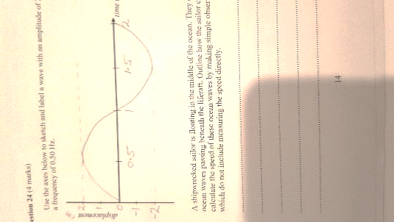

Marker feedback: (current average 0.86)

This question was answered reasonably well although many students did not label axis.

**24.b.**

|  |  |
| --- | --- |
| **Marking Criteria** | **Marks** |
| * method for calculating wave speed is outlined fully | **2** |
| * method stated is incomplete or only observations required identified | **1** |

The sailor should time the period of the waves, T, i.e. the time between successive crests; the wavelength, λ, or distance between successive crests needs to be measured, and then use *v = f*λ to calculate the speed of the waves.

Marker feedback: (current average: 1.05)

This question was answered reasonably well. Answers that included adjusting the boats speed to match that of a wave was not accepted as it was given in the question the sailors were in a life raft. This was assumed to be powerless.

**Booklet 2 - Andrew**

**25a.**

|  |  |
| --- | --- |
| **Marking Criteria** | **Marks** |
| * **correct quantity identified** | **1** |

Velocity

Correct answer only corrected. Mean = 0.49

Approximately half of the candidature recognised that velocity was the rate of change of displacement

**25b.**

|  |  |
| --- | --- |
| **Marking Criteria** | **Marks** |
| * correct explanation for both positive and negative gradients given | **2** |
| * Correct explanation for EITHER positive or negative gradient given | **1** |

The positive gradient represents motion away from the starting point (zero displacement or x=0) to the point of maximum displacement. The negative gradient represents motion from point of maximum displacement back to the starting point (x=0)

**Marker feedback: Mean = 0.93/2**

**Approximately 40 students were able to explain the motion was a repetitive motion and that the reason for the change in gradient was the change in direction after the lady reached her maximum displacement and was returning to the starting point.**

**26.a.**

|  |  |
| --- | --- |
| **Marking Criteria** | **Marks** |
| * Correct answer calculated | **2** |
| * Attempted calculation but with an error or units not given or incorrect | **1** |

U= mgh

U = 6.0 x 9.8 x 1.12

U = 65.86J

**26.b.**

|  |  |
| --- | --- |
| **Marking Criteria** | **Marks** |
| * Correct answer calculated | **2** |
| * Attempted calculation but with an error or units not given or incorrect | **1** |

Power = work/ Δt t = 7.3 x (24 x 60 x 60) = 630720s

= 65.86/630720

= 1.044 x 10-4 W

**Marker feedback:**

**Part a Mean = 1.55/2**

**Question quite well done with most students being able to calculate the change in potential energy**

**Part B Mean = 0.99/5**

**Approximately 30 students were able to calculate the power developed by the clock.**

**The most common error was failing to convert time back to seconds for substitution into the power equation.**

**27.**

|  |  |
| --- | --- |
| **Marking Criteria** | **Marks** |
| * Explanation of constructive interference is thorough and correct * diagram of constructive interference is complete and correct * explanation of destructive interference is thorough and correct * diagram of destructive interference is complete and correct | **4** |
| * one of the above missing or incorrect | **3** |
| * two of the above (4) missing or incorrect | **2** |
| * three of the above (4) missing or incorrect | **1** |

Constructive interference occurs two waves in phase with each other interfere and the sum of their individual amplitudes is greater than that of the individual waves alone. Destructive interference occurs when two waves combine to produce an amplitude that is less than the amplitude of either of the individual waves.

[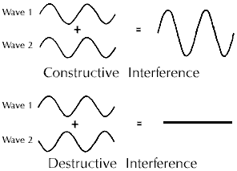](http://www.google.com.au/url?sa=i&rct=j&q=&esrc=s&source=images&cd=&ved=2ahUKEwi4trqc197cAhVEvbwKHXgwCy8QjRx6BAgBEAU&url=http://electron6.phys.utk.edu/light/5/interferometer.htm&psig=AOvVaw26SN7oMtPjHzuPSxA1CP8u&ust=1533859786423123)

Complete destructive interference does not have to be shown. Diagram needs to show resultant wave with smaller amplitude than either individual wave in a phase pattern that would produce resultant wave.

**Marker feedback:**

**Mean 1.37/4**

**The question required students to draw diagrams to illustrate both constructive and destructive interference. The most common error was failure to draw a diagram which reduced the maximum mark to 2. Diagrams needed to be accurately drawn to clearly indicate phenomena. For constructive interference it was important to illustrate the waves as in phase with waves out of phase for destructive interference. Diagrams that were poorly constructed or shared a lack of planning were not rewarded.**

**28.a.**

|  |  |
| --- | --- |
| **Marking Criteria** | **Marks** |
| * Newtons 3rd Law is correctly applied to the flea and surface | **2** |
| * One aspect of Newtons 3rd Law is correctly applied to the flea or the surface | **1** |

When the flea pushes (down) on the surface, the surface pushes back / upwardswith an equal (magnitude of) force

[A statement of Newton’s 3rd law gets no marks – it must be applied]

**28.b.**

|  |  |
| --- | --- |
| **Marking Criteria** | **Marks** |
| * Correct answer calculated | **2** |
| * Attempted calculation but with an error or units not given or incorrect | **1** |

**Either:**

Selects v2 = u2 + 2as **Or** two appropriate equations of motion

(0.95)2 = 2 × a × (0.44 × 10–3) = 1026ms–2

**Or**

changing Ke = work done (as legs expand)

ΔKe = average F × height

½ m (0.95)2 = m × a × (0.44 × 10–3)

½ (0.95)2 = (0.44 × 10–3)a

= 1026 m s–2

**Marker feedback:**

**Part a Mean = 0.97 Approximately 35 students were able to link the action reaction force in the jumping of the flea to Newton’s Third Law. The most common error was merely stating Newton’s Third Law or not linking the action reaction forces in the flea jumping to Newton’s Third Law.**

**Part b Mean = 1.07/2**

**Approximately 40 students were able to choose an appropriate equation and calculate the acceleration of the flea. Common errors were substituting 1000 into an equation and proving the acceleration was equal to 1000 and failing to work in SI Units (converting mm to m).**

**29.**

|  |  |
| --- | --- |
| **Marking Criteria** | **Marks** |
| * Correct diagram for opposite poles drawn with arrows from N to S * Correct explanation for interaction given (attraction must be used) * Correct diagram for same poles drawn with arrows from N to S * Correct explanation for interaction given (repulsion must be used) | **4** |
| * One of the above omitted OR arrows drawn incorrectly on one diagram OR attraction or repulsion not used in answer | **3** |
| * Two of the above (4) omitted OR only diagrams drawn OR only explanation given | **2** |
| * An attempt is made at explaining the forces between like and opposite poles | **1** |

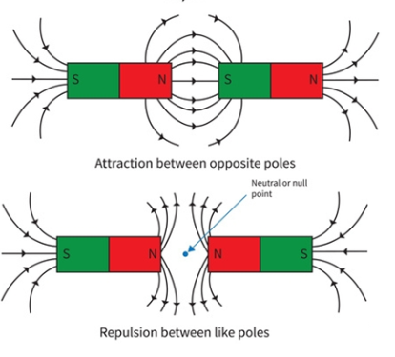

Between two like poles the forces are repulsive. This means that the poles are repelling each other and are pushing apart. The forces are in an opposite direction. The magnetic field lines diverge

Between two opposite poles, the forces are attractive. This means the poles are attracting each other. The magnetic field lines converge.

(Accept single lines as attractive or repulsive force as long as pairs of forces are shown as equal and opposite)

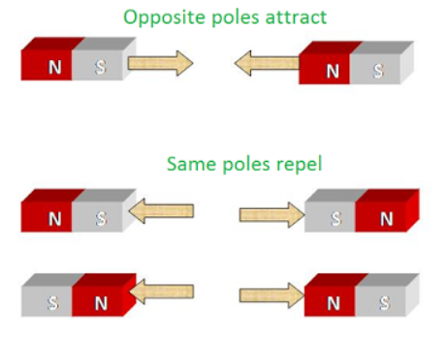

**Marker feedback:**

**Mean = 2.55/4**

**This question was reasonably well done. The most common error again was failure to draw diagrams as required, this cost 2 marks. Other common errors were drawing field lines in the wrong direction, drawing field lines crossing over each other and not showing the correct direction of field lines at both ends of a magnet. Written explanations had to include the terms attraction and repulsion to explain behaviour.**

**Booklet 3 - Ed**

**30.a.**

|  |  |
| --- | --- |
| **Marking Criteria** | **Marks** |
| * Correct answer calculated | **2** |
| * Attempted calculation but with an error or units not given or incorrect | **1** |

Q = mcΔT

= 0.150 x 4010 x 60

= 36.09kJ

if calculated in g not kg 0.5 marks deducted.

**30.b.**

|  |  |
| --- | --- |
| **Marking Criteria** | **Marks** |
| * A Correct assumption given | **1** |

All energy from the steam is transferred to the milk. No energy is lost to the surroundings

**31.a.**

|  |  |
| --- | --- |
| **Marking Criteria** | **Marks** |
| * Correct calculations resulting in correct answer | **2** |
| * Correct basis for calculations with error made or units not given or incorrect | **1** |

To B: speed over ground = 140 – 40 =100 km h-1; time = dist/speed = 100 km/100 km h-1 = 1 hour

To return: speed over ground = 140 + 40 = 180 km h-1; time = dist/speed = 100/180 km h-1 = 0.556 hr = 33 min 20 s

Total time = 1hr 33 min 20 s

**31.b.**

|  |  |
| --- | --- |
| **Marking Criteria** | **Marks** |
| * Correct diagram drawn * Diagram used with correct calculation to obtain correct angle * Correct heading given | **2** |
| * Diagram is drawn correctly or looks similar   OR   * diagram is incorrect but used to find a heading without further error | **1** |

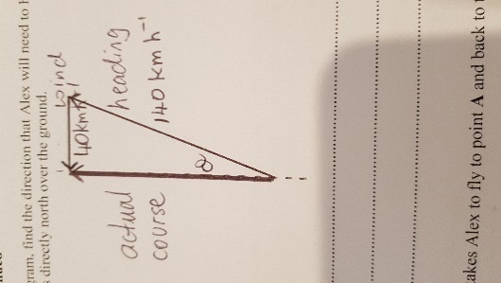

Using the diagram:



Alex must head N17°E so that the plane travels directly north.

**31.c.**

|  |  |
| --- | --- |
| **Marking Criteria** | **Marks** |
| * All necessary calculations performed correctly | **2** |
| * Alex’s speed over the ground is calculated | **1** |

speed, v, found from previous triangle: v2 + 402 = 1402



time = distance/speed = 200 km / 134.16 km h-1 = 1.4908 hr = 1 hr 29 min 27 s

**31.d.**

|  |  |
| --- | --- |
| **Marking Criteria** | **Marks** |
| * An appropriate prediction is given | **1** |

Neither plane could make headway towards their destinations – the race would go nowhere.

**Marker feedback:**

**32.a.**

|  |  |
| --- | --- |
| **Marking Criteria** | **Marks** |
| * A relevant investigation identified * Specific risks and control measures which are relevant stated | **2** |
| * A relevant investigation identified * A specific risk and a relevant control stated | **1** |

When making the solar water heater the metal container became very hot during use. To avoid burns an oven glove was used when handling the container.

To make the solar water heater we used a sharp knife to cut the cardboard box. The knife was kept covered by its protective case when not in use to avoid accidental cuts.

2 risks were required with appropriate controls. Blinding- goggles, burning – gloves, crushing feet – shoes were accepted. The risk had to be relevant and control reasonable.

**32.b.**

|  |  |
| --- | --- |
| **Marking Criteria** | **Marks** |
| * The description refers to at least two factors that aid reliability * The meaning of reliability implied is correct | **2** |
| * The description refers to one factor to ensure reliability | **1** |

Reliability is how repeatable the results of an investigation are. The method must be sufficiently detailed so that there is no ambiguity in how any apparatus is used, or measurements made.

Accepted answers: compare with others, detailed method so others can repeat, check results are similar, repetition

**Marker feedback:**

**33,**

|  |  |
| --- | --- |
| **Marking Criteria** | **Marks** |
| * An appropriate advantage and a disadvantage are outlined | **2** |
| * Either an advantage or a disadvantage is outlined | **1** |

Models are used to represent a construct or relationship that is believed to exist. They may be used to assist in the understanding of the reality through visualisation, simplification or analogy but may also have limitations in that they may be too simple.

Marker feedback: most students can demonstrate a property

**34.a.**

|  |  |
| --- | --- |
| **Marking Criteria** | **Marks** |
| * Explanation is thorough and relevant | **2** |
| * A partial explanation is offered | **1** |

The plotted points have inherent uncertainty. To establish a relationship between the variables, a line of best fit is more useful as it averages out those uncertainties in the individual measurements.

Accepted answers: averages out error,

**34.b.**

|  |  |
| --- | --- |
| **Marking Criteria** | **Marks** |
| * correct answer provided | **1** |

3.8 x 108m

No marks deducted for incorrect or missing units